Project Design Phase-II
Data Flow Diagram & User Stories

Date | 9 July 2026
Team ID | SWTID-2026-2791
Project Name | OptiCrop: Smart Agricultural Production Optimization Engine
Maximum Marks | 4 Marks

Data Flow Diagrams:
A Data Flow Diagram (DFD) is a traditional visual representation of the information flows within a system. A neat and clear DFD can depict the right amount of the system requirement graphically. It shows how data enters and leaves the system, what changes the information, and where data is stored.

Example: (Simplified)
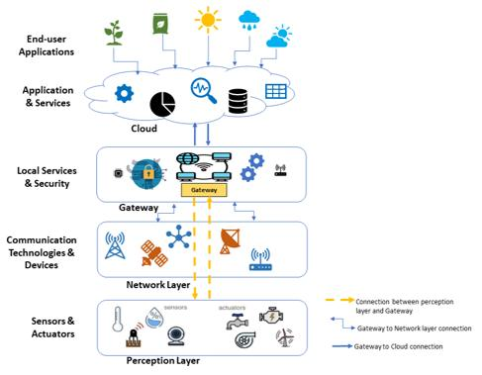
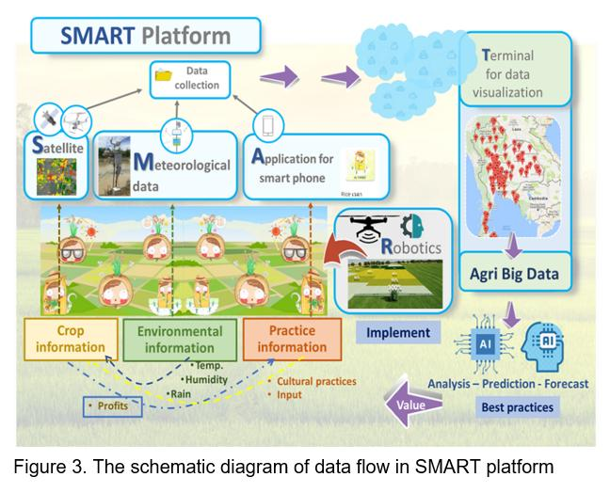

User Stories
Use the below template to list all the user stories for the product.
User Type | Functional Requirement (Epic) | User Story Number | User Story / Task | Acceptance criteria | Priority | Release
Customer (Mobile user) | Registration | USN-1 | As a user, I can register for the application by entering my email, password, and confirming my password. | I can access my account / dashboard | High | Sprint-1
Farmer (Mobile User) | Login | USN-2 | As a user, I will receive confirmation email once I have registered for the application | I can receive confirmation email & click confirm | High | Sprint-1
Farmer (Mobile User) | Crop Recommendation | USN-3 | As a user, I can register for the application through Facebook | I can register & access the dashboard with Facebook Login | Low | Sprint-2
Farmer (Mobile User) | Yield Prediction | USN-4 | As a user, I can register for the application through Gmail | Predicted yield is shown | Medium | Sprint-1
Farmer (Mobile User) | Fertilizer Recommendation | USN-5 | As a user, I can log into the application by entering email & password | Suitable fertilizers are displayed. | High | Sprint-1
Farmer (Mobile User) | Weather Monitoring | USN-6 | As a farmer, I can view current weather and forecast information | Weather details are available on dashboard | Medium | Sprint-2
Farmer (Mobile User) | Dashboard | USN-7 | As a farmer, I can view crop recommendations, yield predictions, and alerts in one dashboard | Dashboard displays all relevant information | High | Sprint-2
Customer Care Executive | Advisory Services | USN-8 | As an expert, I can provide crop management advice to farmers | Farmers can view expert recommendations | Medium | Sprint-2
Administrator | User Management | USN-9 | As an admin, I can manage farmer accounts | Admin can add, update, or delete users | High | Sprint-1
Administrator | Dataset Management | USN-10 | As an admin, I can upload and update agricultural datasets | System uses updated datasets for predictions | High | Sprint-2
Administrator | Reports | USN-11 | As an admin, I can generate reports on crop recommendations and yield predictions | Reports are generated successfully | Medium | Sprint-3
Administrator | System Monitoring | USN-12 | As an admin, I can monitor system performance and user activity | Monitoring dashboard is available | Medium | Sprint-3

